WIPRO CAPSTONE PROJECT
Defect Report

BlazeDemo Flight Booking Automation Framework
Selenium WebDriver · TestNG · Maven · ExtentReports · Jenkins · Docker

Project Name | BlazeDemo Flight Booking Automation Framework
Document Type | Defect Report
Prepared By | Mr. Baivab Sarkar
Mentor/ Trainer | Mrs. Vaishali Sonanis
Application Under Test | BlazeDemo
URL | https://blazedemo.com/
Defect Tracker | JIRA [BLAZEDEMO]
Total Defects | 7
Date | 13th June 2026

1. Introduction
This document summarizes the defects identified during functional testing of the BlazeDemo Flight Booking application. The issues were observed across various flight booking features and have been recorded in JIRA with relevant details such as reproduction steps, expected and actual outcomes, severity and priority to support defect management and resolution.

2 Defects Logged in JIRA:
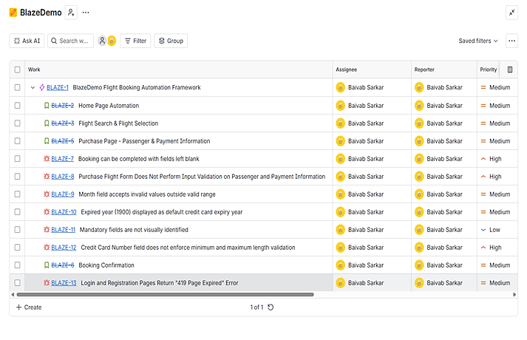

3. JIRA Defect Report
Defect ID | Title | Severity | Priority | Module | Status
BLAZE-7 | Booking can be completed with fields left blank | High | High | Purchase Page | TO DO
BLAZE-8 | Purchase Flight Form Does Not Perform Input Validation on Passenger and Payment Information | High | High | Purchase Page | TO DO
BLAZE-9 | Month field accepts invalid values outside valid range | Medium | Medium | Purchase Page | TO DO
BLAZE-10 | Expired year (1900) displayed as default credit card expiry year | Medium | Medium | Purchase Page | TO DO
BLAZE-11 | Mandatory fields are not visually identified | Low | Low | Purchase Page | TO DO
BLAZE-12 | Credit Card Number field does not enforce minimum and maximum length validation | Medium | High | Purchase Page | TO DO
BLAZE-13 | Login and Registration Pages Return "419 Page Expired" Error | High | High | Login Page / Registration Page | TO DO

4. Individual Defect Details
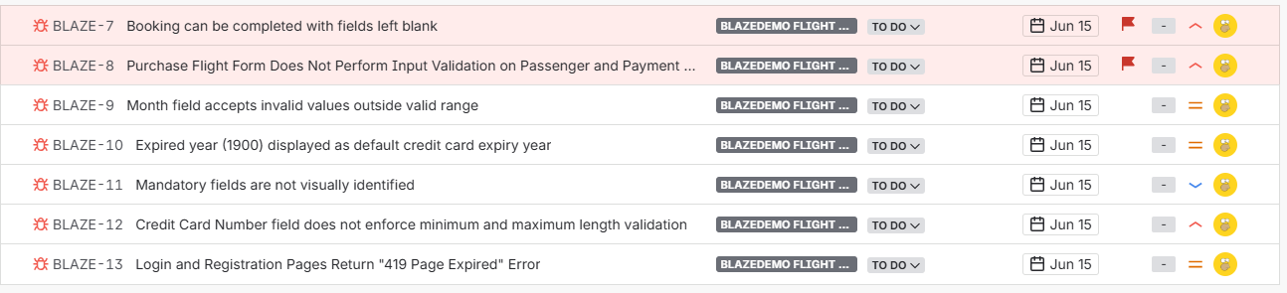

DEF001 – Registration Pages Return 419 Page Expired Error
Field | Details
Defect ID | DEF001
Test Case ID | TC005
Test Case Name | Verify Registration Page
Module | Authentication Module
Severity | Critical
Priority | Medium
Raised By | Baivab Sarkar
Status | To Do

Description: Application displays "419 Page Expired" when attempting user registration. Users are unable to create new accounts.
Business Impact: New users cannot register in the application, making authentication functionality unavailable.
Preconditions
- Application is accessible.
- Registration page is available.
- User is not logged in.
Steps to Reproduce
- Launch the application.
- Click Register.
- Enter valid registration details.
- Click Register button.
- Observe the response.
Expected Result: User account should be created successfully and redirected to the appropriate page.
Actual Result: Application displays 419 Page Expired.
Attachment:
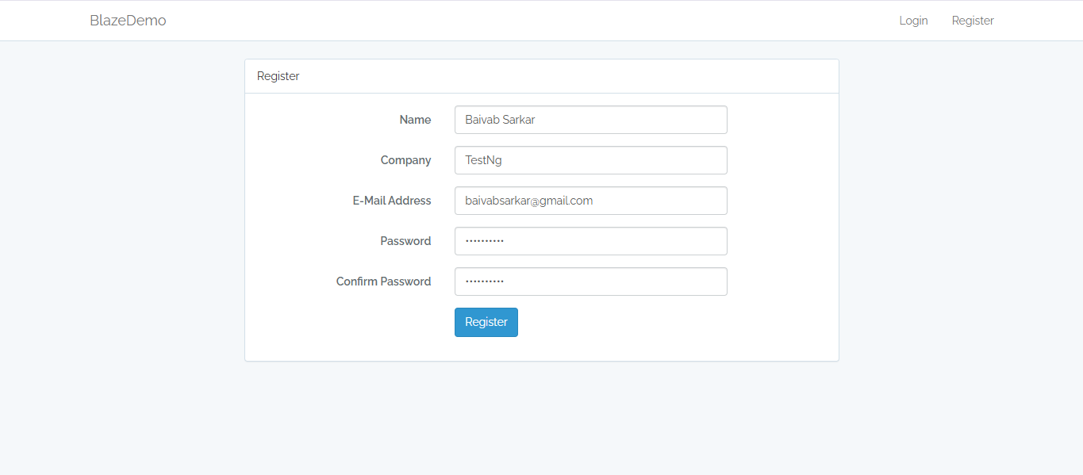


JIRA Report: BLAZE-13
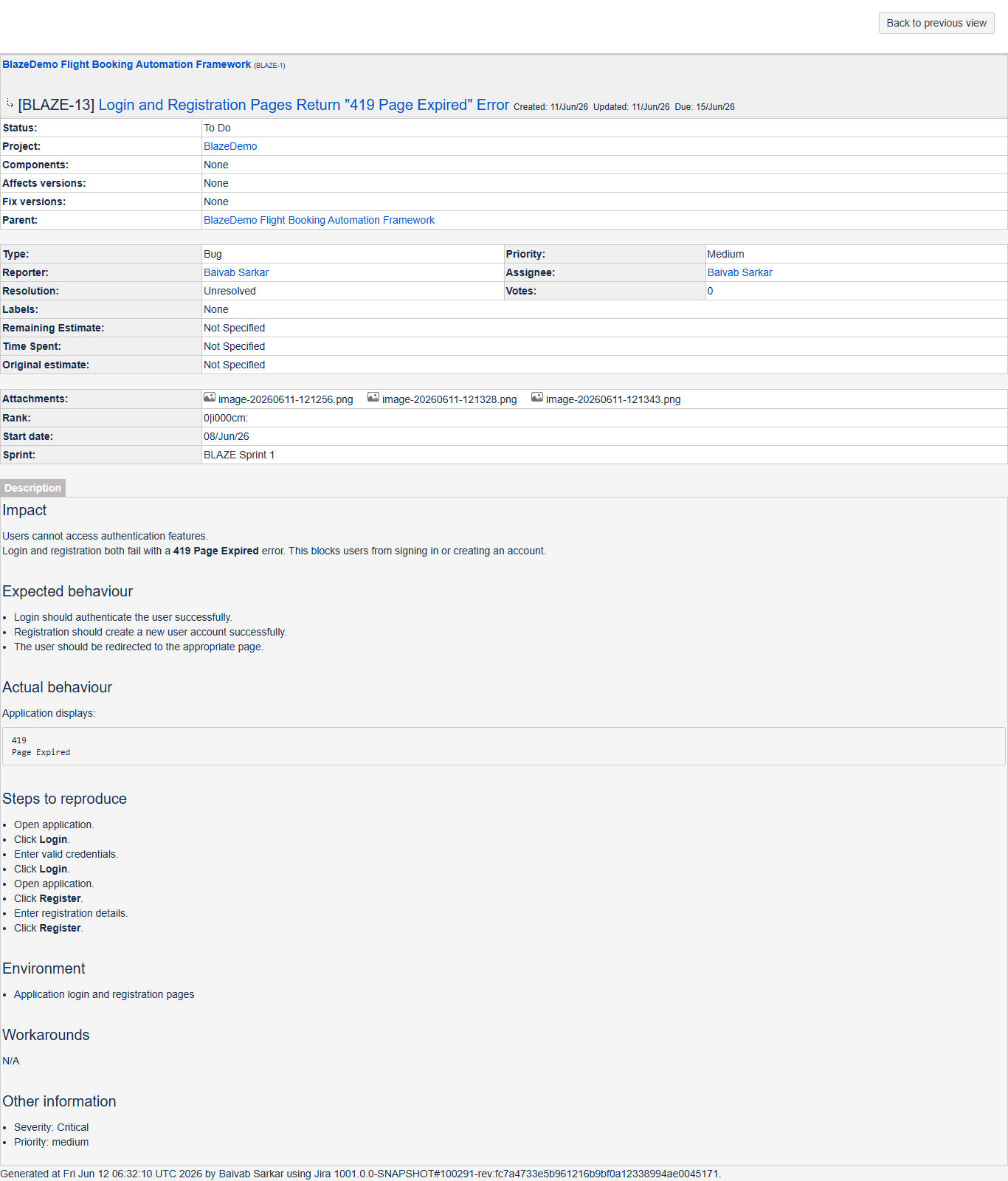

DEF002 – Login Pages Return 419 Page Expired Error
Field | Details
Defect ID | DEF002
Test Case ID | TC006
Test Case Name | Verify Login Page
Module | Authentication Module
Severity | Critical
Priority | Medium
Raised By | Baivab Sarkar
Status | To Do

Description: Application displays "419 Page Expired" when valid login credentials are submitted.
Business Impact: Existing users cannot access the application.
Preconditions
- Application is accessible.
- Valid user credentials exist.
Steps to Reproduce
- Launch the application.
- Click Login.
- Enter valid credentials.
- Click Login button.
- Observe the response.
Expected Result: User should be authenticated successfully and redirected to the dashboard/home page.
Actual Result: Application displays 419 Page Expired.

Attachment:
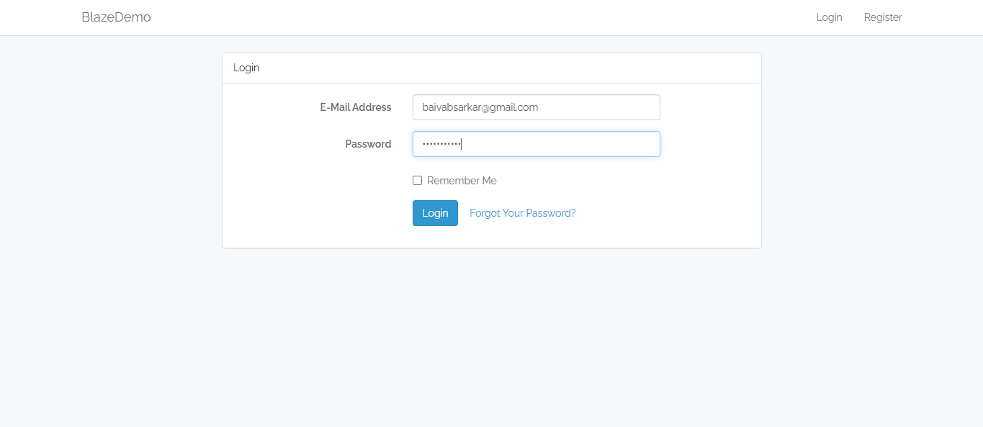


JIRA Report: BLAZE-13


DEF003 – Booking Can Be Completed With Fields Left Blank
Field | Details
Defect ID | DEF003
Test Case ID | TC007
Test Case Name | Booking With Blank Mandatory Fields
Module | Purchase Module
Severity | Critical
Priority | High
Raised By | Baivab Sarkar
Status | To Do

Description: The application allows flight booking completion even when all mandatory passenger and payment fields are left blank.
Business Impact: Invalid booking records can be generated, resulting in compromised data integrity.
Preconditions
- Application is accessible.
- Flight search completed.
- Purchase page is displayed.
Steps to Reproduce
- Search and select any flight.
- Navigate to Purchase Page.
- Leave all passenger and payment fields blank.
- Click Purchase Flight.
Expected Result: System should display validation messages and prevent booking submission.
Actual Result: Booking confirmation is generated successfully.

Attachment:
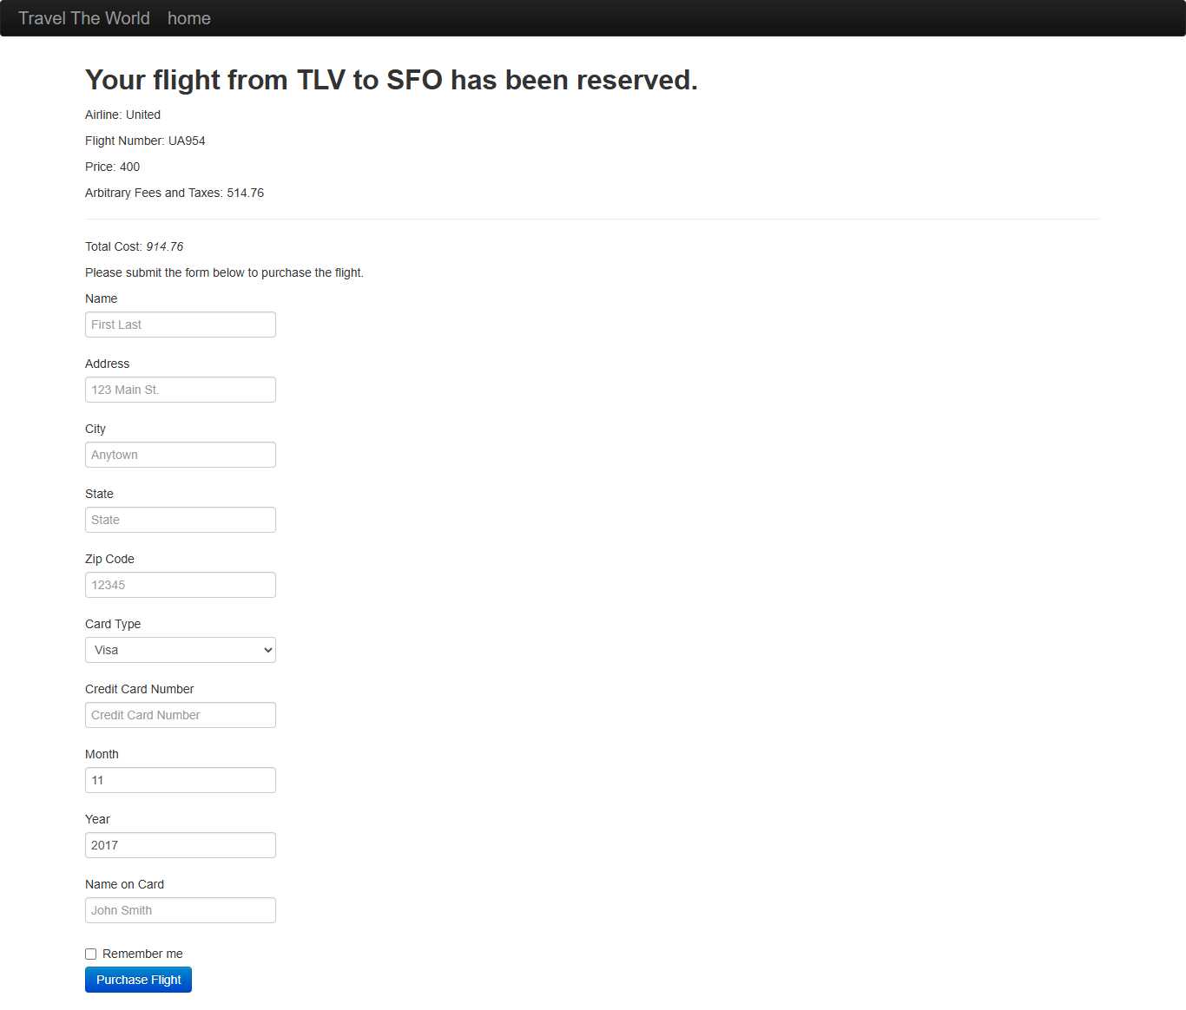
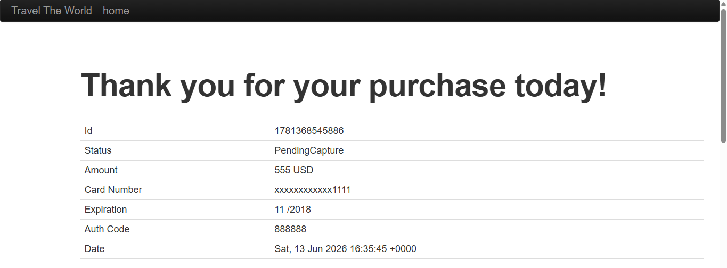
JIRA Report: BLAZE-7
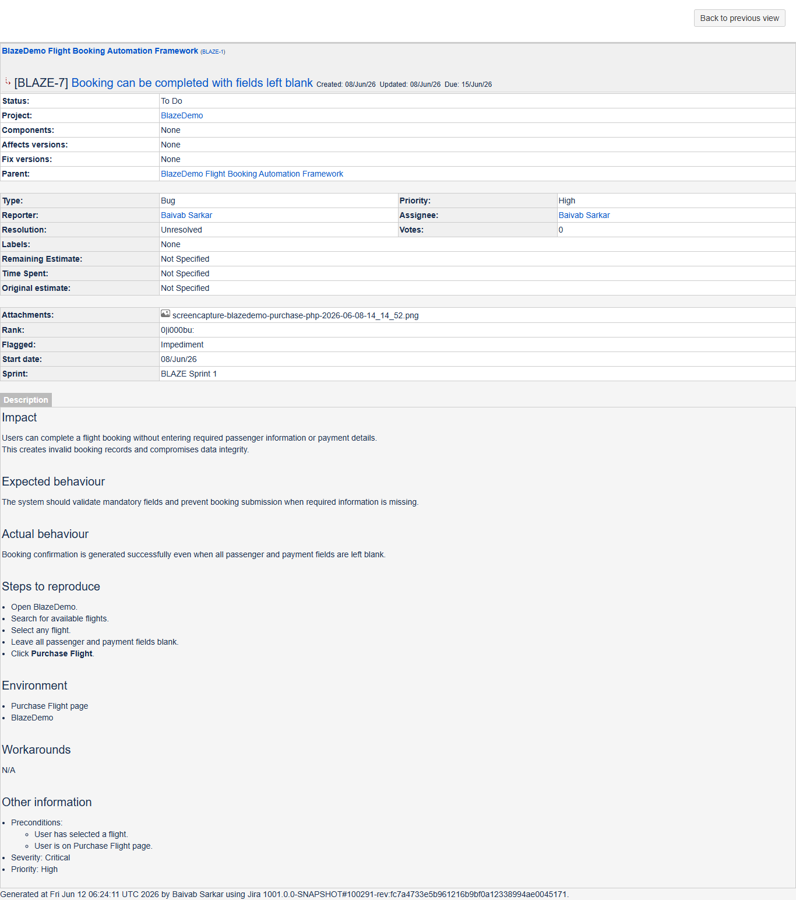

DEF004 – Purchase Flight Form Does Not Perform Input Validation on Passenger and Payment Information
Field | Details
Defect ID | DEF004
Test Case ID | TC008
Test Case Name | Invalid Passenger Information
Module | Purchase Module
Severity | Critical
Priority | High
Raised By | Baivab Sarkar
Status | To Do

Description: The Purchase Flight form accepts invalid, numeric-only, and special-character inputs in passenger and payment fields without performing any validation.
Business Impact: Invalid customer and payment information can be stored in the system, resulting in poor data quality and unreliable booking records.
Preconditions
- Application is accessible.
- Flight search completed successfully.
- Purchase Page is displayed.
Steps to Reproduce
- Search and select any flight.
- Navigate to Purchase Page.
- Enter invalid data such as:
  - Name = @#$%^
  - Name = 12345
  - City = 12345
  - State = @@@@@
  - Credit Card = ABC123
- Click Purchase Flight
Expected Result: System should validate all passenger and payment information and display appropriate validation messages.
Actual Result: Booking confirmation is generated successfully.

Attachment:
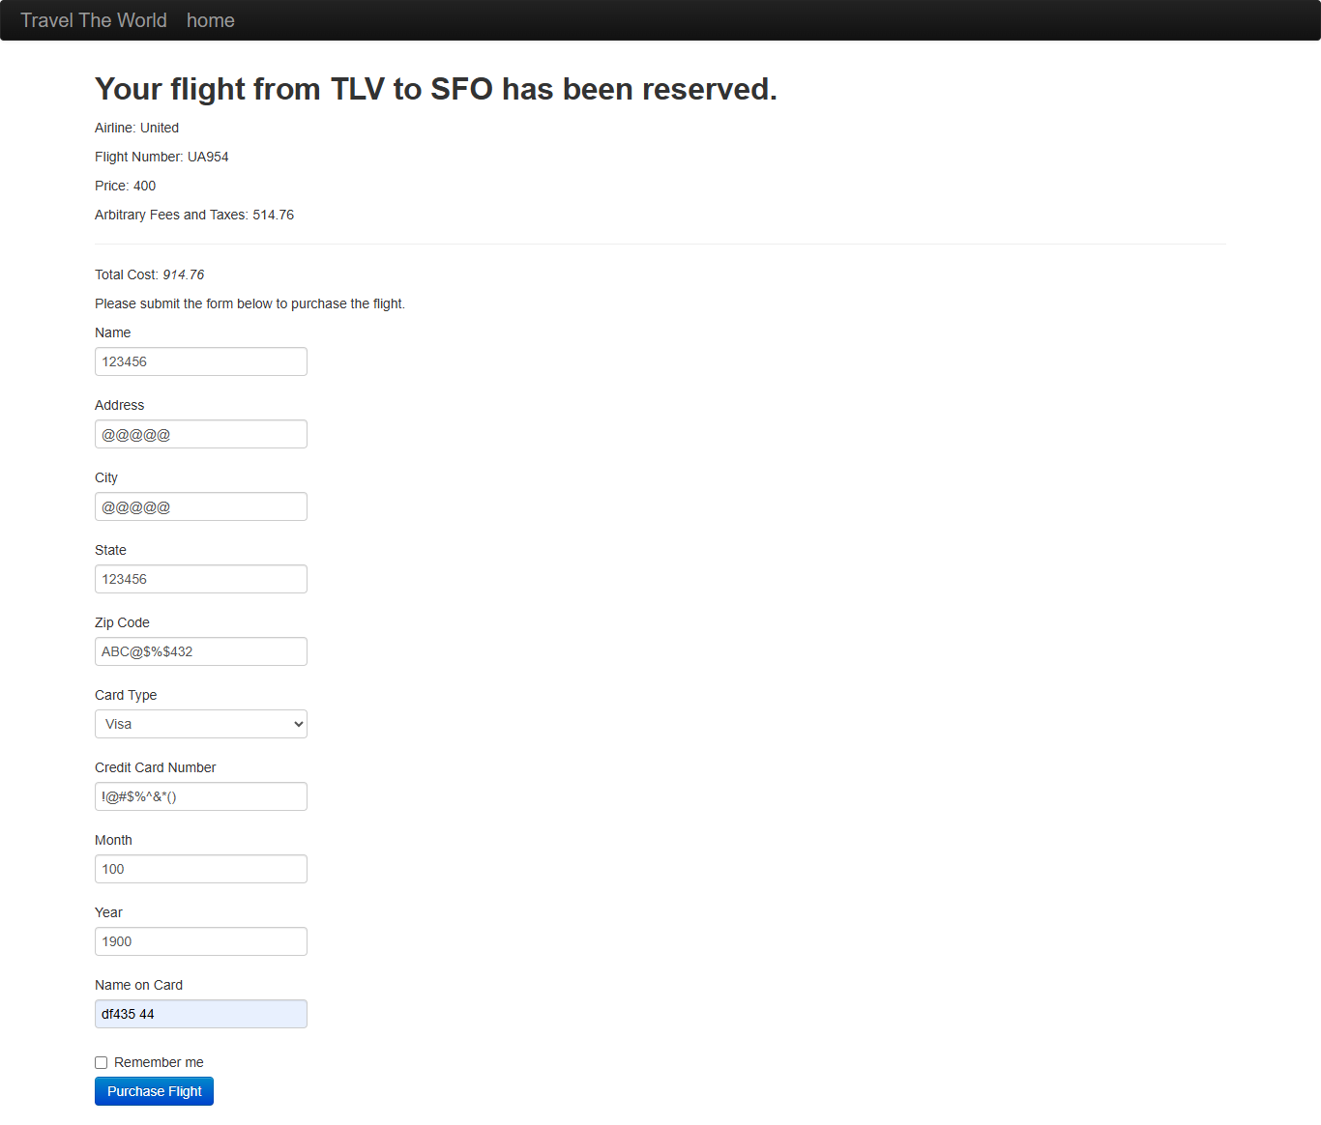

JIRA Report: BLAZE-8
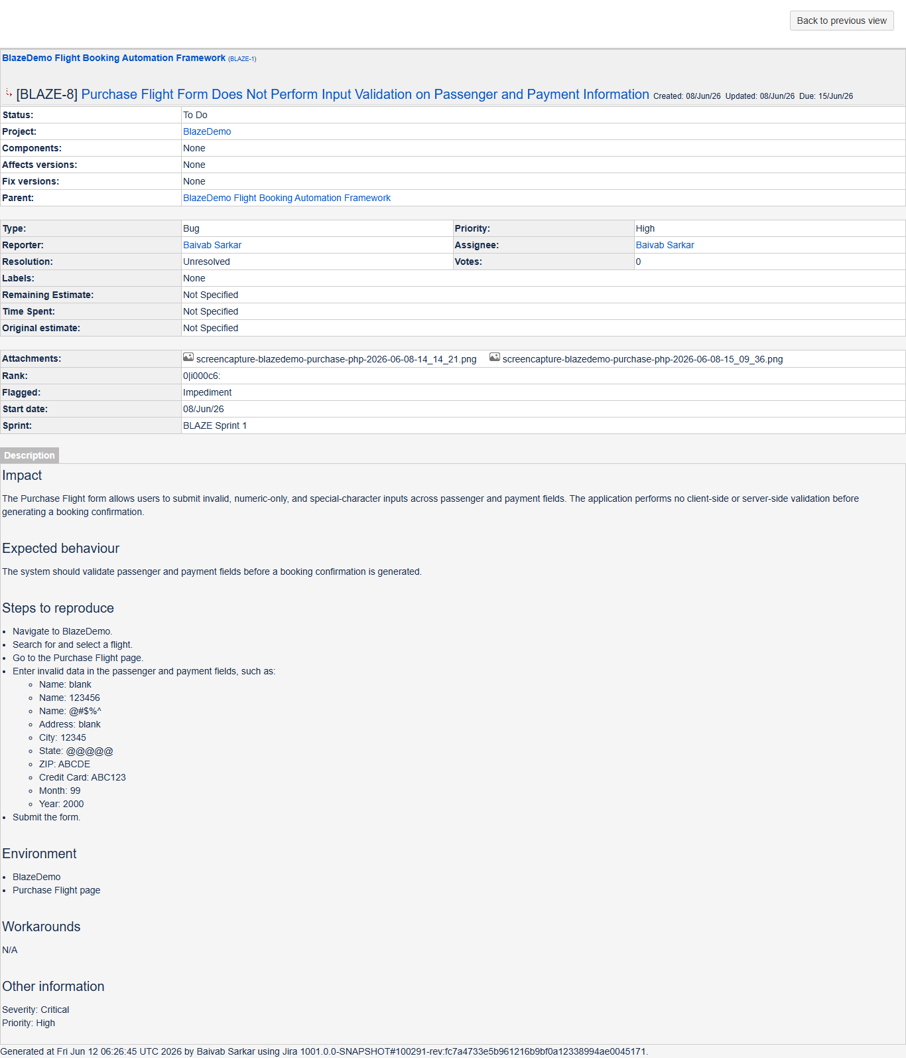

DEF005 – Month Field Accepts Invalid Values Outside Valid Range
Field | Details
Defect ID | DEF005
Test Case ID | TC009
Test Case Name | Invalid Month Validation
Module | Payment Module
Severity | Major
Priority | Medium
Raised By | Baivab Sarkar
Status | To Do

Description: The Month field accepts values outside the valid range of 1–12.
Business Impact: Invalid payment information can be submitted and stored within booking records.
Preconditions
- Application is accessible.
- Flight search completed successfully.
- Purchase Page is displayed.
Steps to Reproduce
- Search and select any flight.
- Navigate to Purchase Page.
- Enter valid passenger information.
- Enter Month = 99.
- Click Purchase Flight
Expected Result: System should reject values outside the range 1–12 and display a validation message.
Actual Result: Booking confirmation is generated successfully.
Attachment:
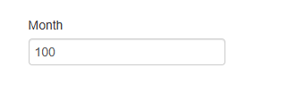

JIRA Report: BLAZE-9
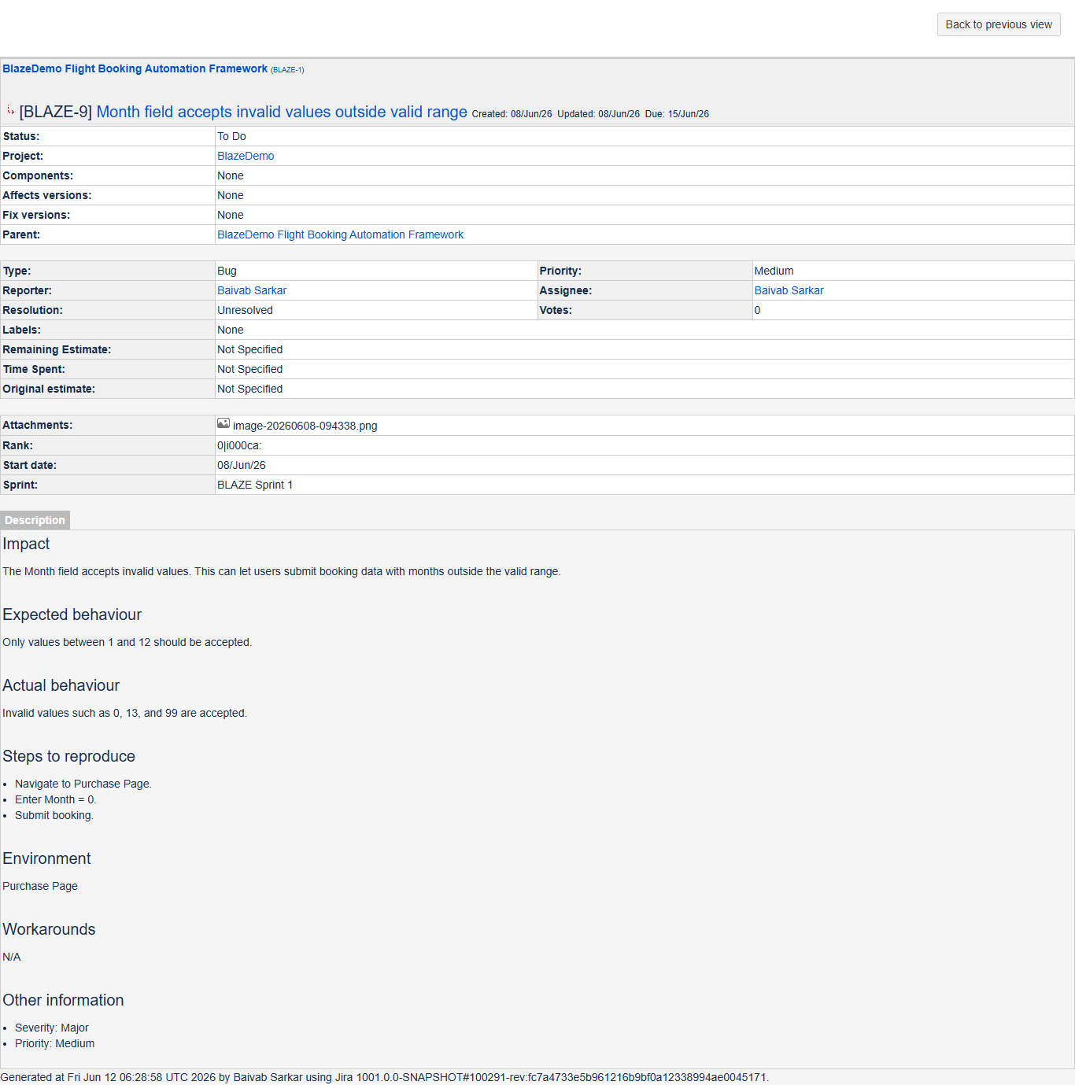

DEF006 – Expired Year (1900) Displayed as Default Credit Card Expiry Year
Field | Details
Defect ID | DEF006
Test Case ID | TC010
Test Case Name | Expired Year Validation
Module | Payment Module
Severity | Medium
Priority | Medium
Raised By | Baivab Sarkar
Status | To Do

Description: The application accepts an expired year value (1900) in the credit card expiry year field.
Business Impact: Users can submit invalid payment information which may result in payment failures.
Preconditions
- Application is accessible.
- Flight search completed successfully.
- Purchase Page is displayed.
Steps to Reproduce
- Search and select any flight.
- Navigate to Purchase Page.
- Enter valid passenger details.
- Enter Year = 1900.
- Click Purchase Flight
Expected Result: System should reject expired years and display an appropriate validation message.
Actual Result: Booking confirmation is generated successfully.
Attachment:
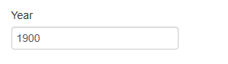

JIRA Report: BLAZE-10
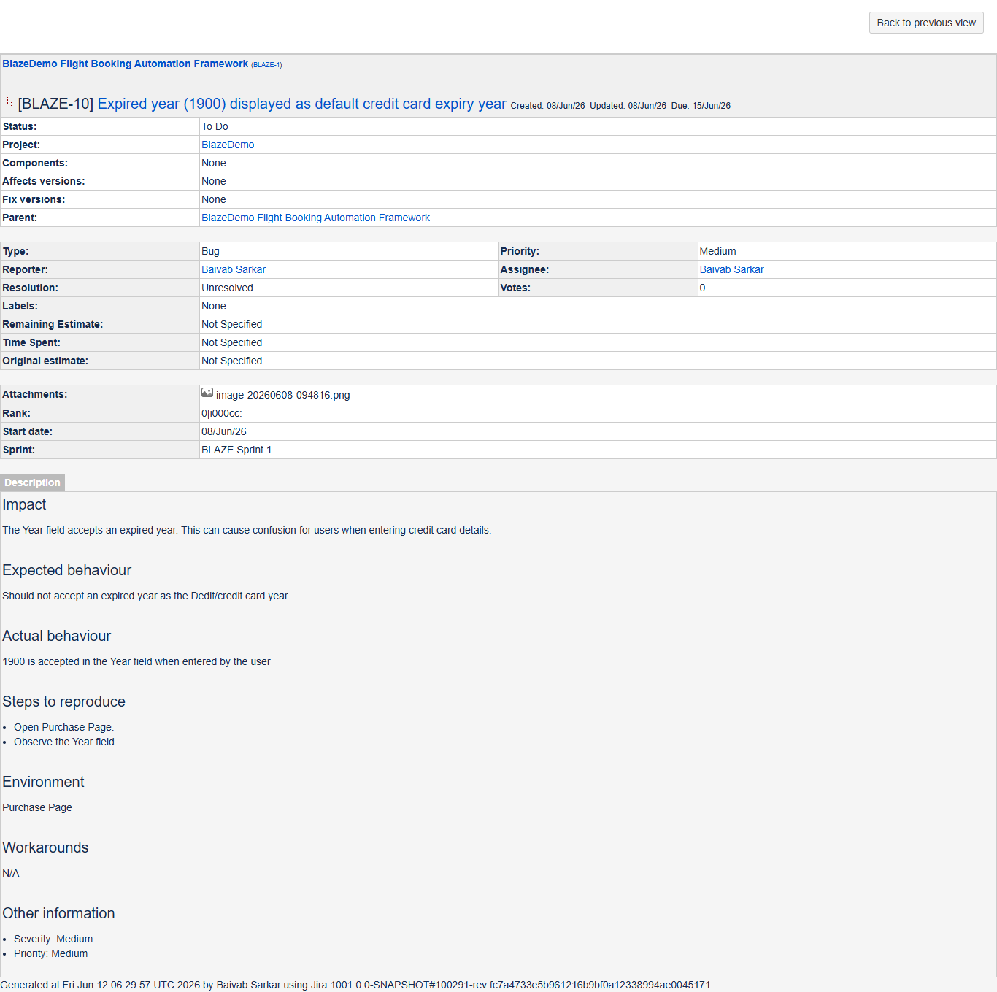

DEF007 – Mandatory Fields Are Not Visually Identified
Field | Details
Defect ID | DEF007
Test Case ID | TC011
Test Case Name | Mandatory Field Indicator
Module | Purchase Module
Severity | Minor
Priority | Low
Raised By | Baivab Sarkar
Status | To Do

Description: Mandatory fields on the Purchase Page are not visually marked as required.
Business Impact: Users may not know which fields must be completed, leading to confusion and reduced usability.
Preconditions
- Application is accessible.
- Flight search completed successfully.
- Purchase Page is displayed.
Steps to Reproduce
- Search and select any flight.
- Navigate to Purchase Page.
- Review all labels and input fields
Expected Result: Mandatory fields should be clearly identified using visual indicators such as an asterisk (*) or "Required" label.
Actual Result: No mandatory field indicators are displayed.
Attachment: NA

JIRA Report: BLAZE-11
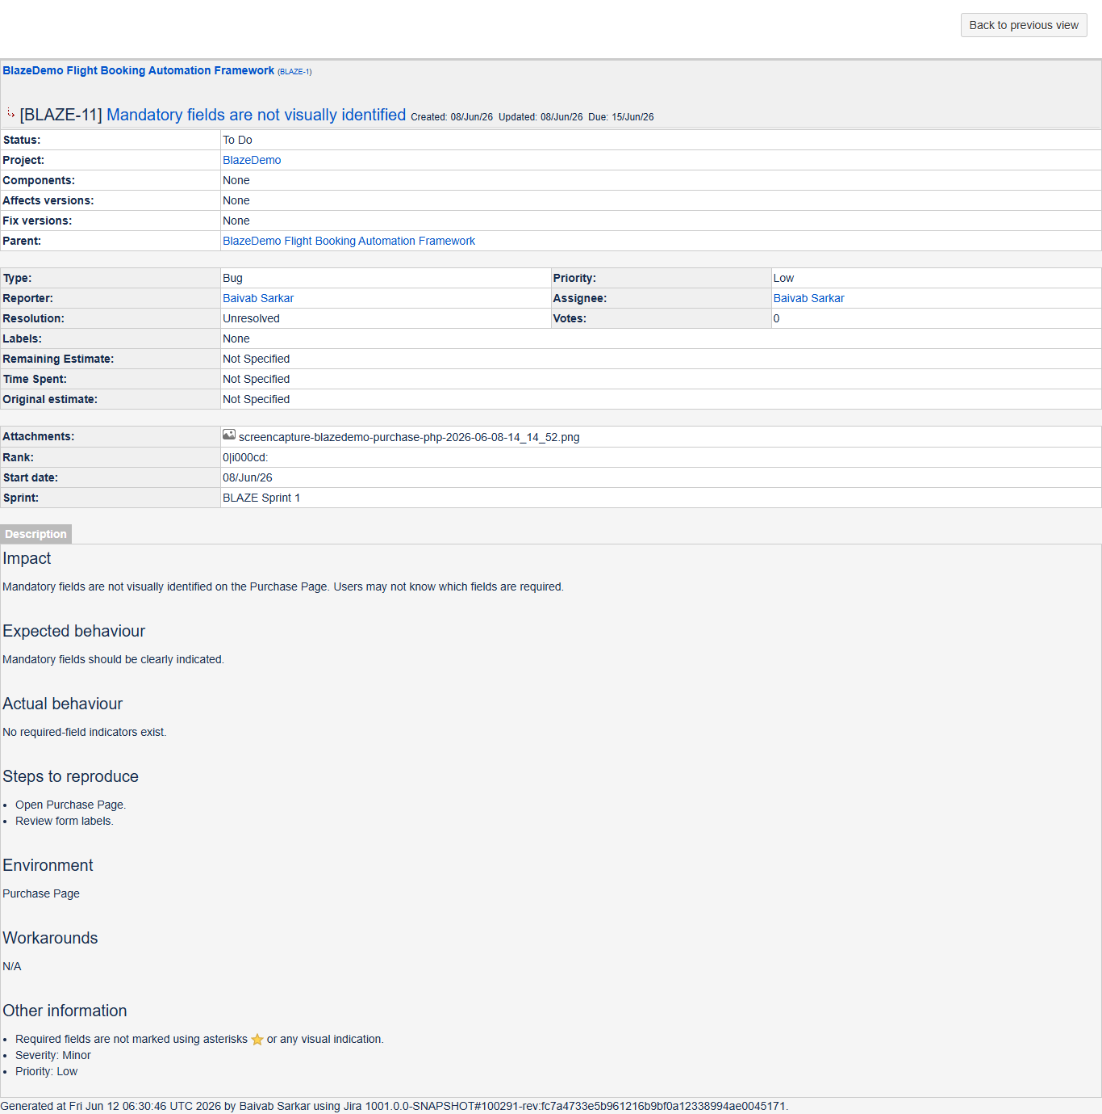

DEF008 – Credit Card Number Field Does Not Enforce Minimum and Maximum Length Validation
Field | Details
Defect ID | DEF008
Test Case ID | TC012
Test Case Name | Credit Card Length Validation
Module | Payment Module
Severity | Major
Priority | High
Raised By | Baivab Sarkar
Status | To Do

Description: The Credit Card Number field accepts card numbers that are shorter or longer than valid card number lengths.
Business Impact: Invalid payment information can be accepted and stored, potentially causing transaction failures.
Preconditions
- Application is accessible.
- Flight search completed successfully.
- Purchase Page is displayed.
Steps to Reproduce
- Search and select any flight.
- Navigate to Purchase Page.
- Enter valid passenger details.
- Enter invalid card numbers:
  - 123
  - 09876543210987654321
- Click Purchase Flight
Expected Result: System should reject card numbers that do not meet the minimum and maximum length requirements.
Actual Result: Booking confirmation is generated successfully.
Attachment:

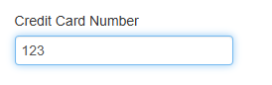
JIRA Report: BLAZE-12
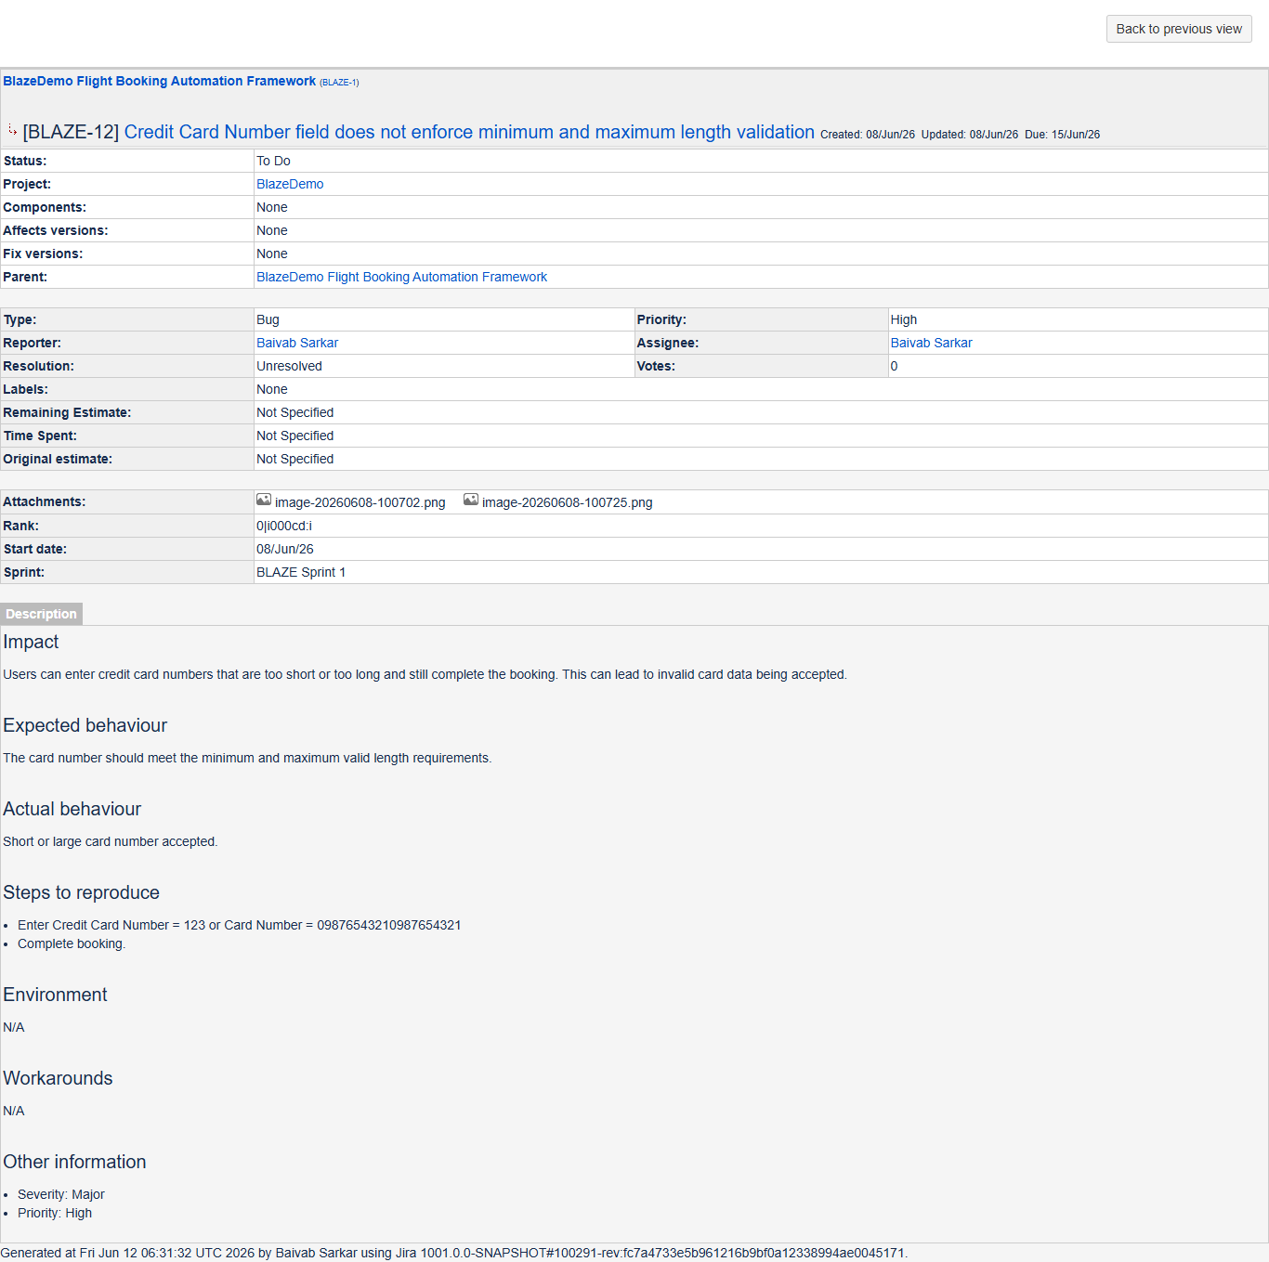

5. Defect Summary (Defect Report.xlse)
Defect identifier | Defect summary | Test Id | JIRA Id | Test case name | Module name
DEF001 | Registration Pages Return 419 Page Expired Error | TC005 | BLAZE-13 | Verify Registration Page | Authentication Module
DEF002 | Login Pages Return 419 Page Expired Error | TC006 | BLAZE-13 | Verify Login Page | Authentication Module
DEF003 | Booking can be completed with fields left blank | TC007 | BLAZE-7 | Booking With Blank Mandatory Fields | Purchase Module
DEF004 | Purchase Flight Form Does Not Perform Input Validation on Passenger and Payment Information | TC008 | BLAZE-8 | Invalid Passenger Information | Purchase Module
DEF005 | Month field accepts invalid values outside valid range | TC009 | BLAZE-9 | Invalid Month Validation | Payment Module
DEF006 | Expired year (1900) displayed as default credit card expiry year | TC010 | BLAZE-10 | Expired Year Validation | Payment Module
DEF007 | Mandatory fields are not visually identified | TC011 | BLAZE-11 | Mandatory Field Indicator | Purchase Module
DEF008 | Credit Card Number field does not enforce minimum and maximum length validation | TC012 | BLAZE-12 | Credit Card Length Validation | Payment Module

Reproducible | Severity | Priority | Raised by | Assigned to | Date of assignment | Status | Snap shots | Fixed by | Date of fixing | Approvals (Manager Name)
Yes | Critical | Medium | Baivab Sarkar |  |  | To Do | Available
Yes | Critical | Medium | Baivab Sarkar |  |  | To Do | Available
Yes | Critical | High | Baivab Sarkar |  |  | To Do | Available
Yes | Critical | High | Baivab Sarkar |  |  | To Do | Available
Yes | Major | Medium | Baivab Sarkar |  |  | To Do | Available
Yes | Medium | Medium | Baivab Sarkar |  |  | To Do | Available
Yes | Minor | Low | Baivab Sarkar |  |  | To Do | Available
Yes | Major | High | Baivab Sarkar |  |  | To Do | N/A

6. Conclusion
A total of 8 defects were identified during testing of the BlazeDemo application across the Authentication, Purchase, and Payment modules. The defects include authentication failures, missing input validations, and UI usability issues. These issues impact system functionality, data integrity, and user experience

